**2019 CURVE TRACER FAULT DIAGNOSIS MANUAL**

(Revision 20201009)

Failures are generally caused by problems in the 3-channel power amplifier B/C/E where failure rates are highest in relays J1/J4 and chips IC204(B)/IC204(A). You can determine where the problem is by following the steps below. Note that IC204 can be installed either as one SMD dual op-amp TP2272, or as two separate through-hole single op-amps OP07.

**Step 0.** Please restore the original factory-default “ads7871_v3s.ini” file to your installation directory and open the curve tracer housing by removing the upper 2 screws at front and lower 2 screws at rear, before proceeding to the next step.

**Step 1.** Run the curve tracer program, select “Options->config” and click “Auto Detect & Get Parameter” as shown in figure 1 below.

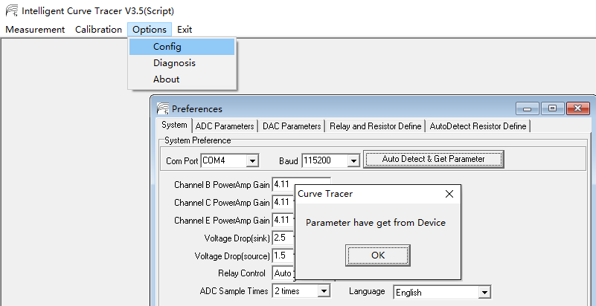

**Figure 1**

**Step 2.** Select menu item “Options->Diagnosis” and set the values as shown in the red box of figure 2 below, then click the “Output” button. At this point the system will set the B channel to output 5V, the C channel to output 15V, and the E channel to output 25V.

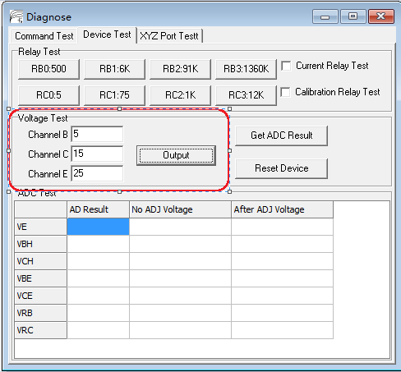

**Figure 2**

Refer to figure 3 when finding the test points for making the following series of measurements.  
Measure the output voltage of “Channel E” between the emitter of Q4 and ground. It should be about 25V. If it is wrong then proceed to the section titled “E output wrong” farther below.

Measure the output voltage of “Channel C” between the emitter of Q2 and ground. It should be about 15V. If it is wrong then proceed to the section titled “C output wrong” farther below.

Measure the output voltage of “Channel B” between the emitter of Q9 and ground. It should be about 5V. If it is wrong then proceed to the section titled “B output wrong” farther below.

If the voltages were correct, it means that the outputs of the DACs and the 3 power amplifier channels are normal, so continue to the next step of this procedure.

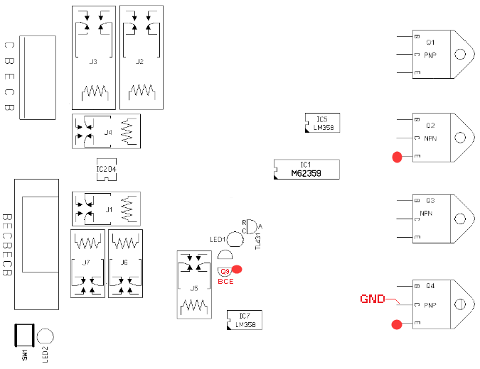

**Figure 3**

**Step 3.** With the dialog from the previous step still open, click the “Get ADC Result” button. The system will use the ADC to measure 7 voltage values VE/VBH/VCH/VBE/VCE/VEB/VRC and display them in the table as shown below.

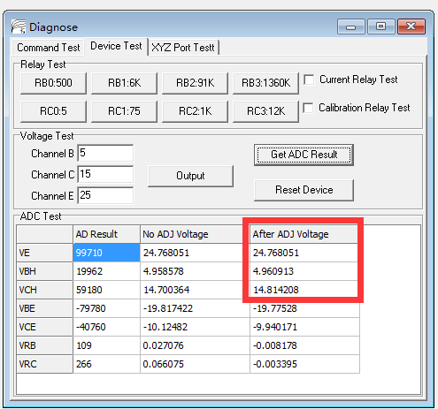

**Figure 4**

Now look at the values indicated by the red box above. Line “VE” shows the measured voltage of “Channel E” which should be close to the 25V value previously measured by multimeter between the emitter Q4 and ground. If it is wrong then jump to section “E measurement error”.

Line “VCH” shows the measured voltage of “Channel C” which should be close to the 15V value previously measured by multimeter between the emitter of Q2 and ground. If it is wrong then jump to section “C measurement error”. Line “VBH” shows the measured voltage of “Channel B” which should be close to the 5V value previously measured by multimeter between the emitter of Q9 and ground. If it is wrong then jump to section “B measurement error”. If the values shown corresponded correctly with the set values then continue to the next step of this procedure.

**Step 4.** Close the Diagnose window if it is still open from the previous step. Select menu item “Measurement->Curve Tracer”, tick the box “Calibration befor measure” and then click the “offset test” button. This should show 4 mixed curves. The abscissa shows the output voltage Ve and the range should be around 2~36. The ordinate range is between -0.005 and +0.005.

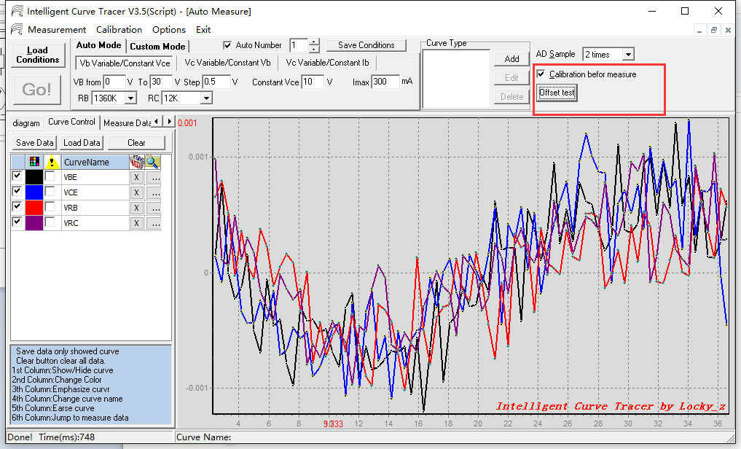

**Figure 5**

If you find that one of the above curves has a large deviation then the correction circuit is not working so jump to section “Correction circuit fault”. If the offset test results were normal then continue to the next step below.

**Step 5.** This is the “Channel C” relay J2/J3 diagnostic. The C channel output voltage passes through an internal 5Ω/75Ω/1KΩ/12KΩ current shunt to measurement terminal C, so connect a 5 watt 200Ω~1KΩ resistor from the C output terminal to ground and use a multimeter to measure the voltage across this resistor. The equivalent circuit is shown in figure 6 below.

**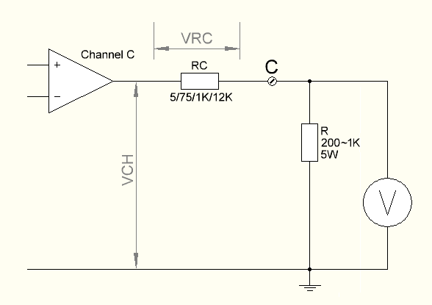  
Figure 6**

Select menu item “Options->Diagnosis”, set “Channel C” value to 30 volts and click the “Output” button. Now cycle through RC3:12K/RC2:1K/RC1:75/RC0:5 by pressing each button in turn while noting the corresponding multimeter reading for each one. Click button “Reset Device” when finished to turn off the output. For example, connecting a 400Ω 5W resistor and setting “Channel C” to 30V yields meter readings of 0.94V for “RC3:12K”, 8.4V for “RC2:1K”, 25V for “RC1:75”, and 29.5V for “RC0:5”, thereby indicating that the relays J2/J3 are good. If the voltage ratios of the above 4 buttons are not correct then there is a problem with J1/J2, the internal shunt resistors or the relay coil drive circuitry.

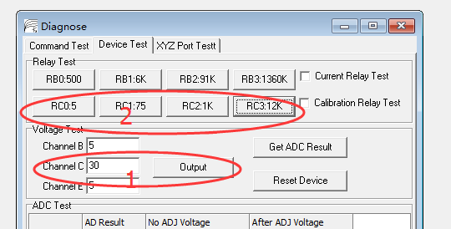

**Figure 7**

**Step 6.** This is the “Channel B” relay J6/J7 diagnostic. The B channel output voltage passes through an internal 500Ω/6KΩ/91KΩ/1360KΩ current shunt to measurement terminal B, so connect a 10KΩ resistor from the B output terminal to ground and use a multimeter to measure the voltage across this resistor. The equivalent circuit is shown in figure 8 below.

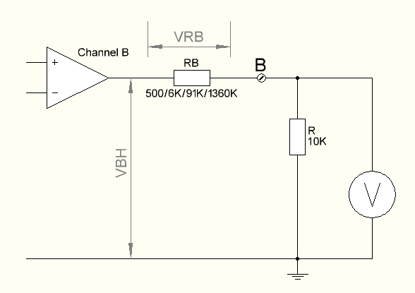

**Figure 8**

Select menu item “Options->Diagnosis”, set “Channel B” value to 30 volts and click the “Output” button. Now cycle through RB3:1360K/RB2:91K/RB1:6K/RB0:500 by pressing each button in turn while noting the corresponding multimeter reading for each one. Click button “Reset Device” when finished to turn off the output. For example, connecting an 11KΩ ¼W resistor and setting “Channel B” to 30V yields meter readings of 0.6V for “RB3:1360K”, 3.2V for “RB2:91K”, 19V for “RB1:6K”, and 28.5V for “RB0:500”, thereby indicating that the relays J6/J7 are good. If the voltage ratios of the above 4 buttons are not correct then there is a problem with J5/J6, the internal shunt resistors or the relay coil drive circuitry.

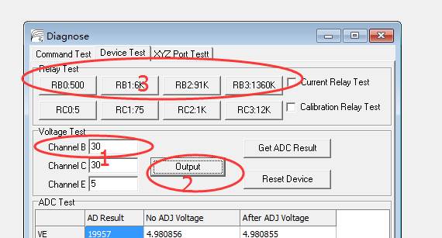

**Figure 9**

This concludes the all procedure steps. If you replaced your “ads7871_v3s.ini” file with factory defaults then restore your original file now or perform a full voltage and current calibration.

**FAILED TEST STEP REMEDIATION INSTRUCTIONS**

**E output wrong**

The E-channel power amplifier pictured below, consists of the lower part B of IC5, R7/218, and Q3/4 to form a power amplifier. The gain is 1+R7/R218 = 1+56K/18K = 4.1, the DAC output voltage is connected to pin 5 of IC5B, and pin 7 of IC5B drives Q3/4 through a 100 ohm resistor. When the E channel is set to output 25V then the DAC output is about 6V. Measuring pin 5 of IC5B can determine whether the DAC is operating normally but if IC5B is abnormal then it will also affect the voltage at pin 5. If the Q3 emitter output voltage is not proportional to the DAC input voltage then check the power amplifier circuit. A common fault occurs when Q3/4 is damaged, resulting in abnormal output current or reverse current. Or Q3/4 may have poor performance and cannot carry the load.

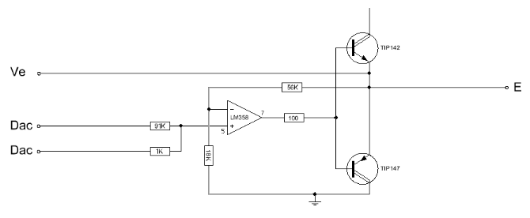

**C output wrong**

The C channel as pictured below, is composed of the upper part A of operational amplifier IC5, R10/208, and Q1/2. The gain is 1+R10/R208 = 1+56K/18K = 4.1, the DAC output voltage is connected to pin 3 of IC5A, and pin 7 of IC5A drives Q1/2 through a 100 ohm resistor. When Channel C is set to output 15V, the DAC output is about 3.6V. Measuring pin 5 of IC5B can determine whether the DAC is operating normally, but if IC5B is abnormal then it will also affect the voltage at pin 5. A common fault occurs when Q1/2 is damaged, resulting in abnormal output current or reverse current. Or Q1/2 may have poor performance and cannot carry the load.

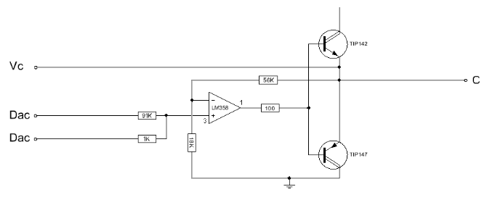

**B output wrong**

Channel B is composed of IC7, Q9/10, J5 and surrounding resistors to form a power amplifier with two working modes, either constant current or constant voltage. When J5 is not energized then the circuit is in constant voltage mode and gain is 4.1, same as in the circuits for E and C above. The DAC output voltage is connected to pin 3 of IC7A, while pin 7 of IC7B drives Q9/10 through a 100 ohm resistor. When the Channel B is set to output 5V, the DAC output is about 1.2V and this can be checked at pin 3 of IC7A to determine whether the DAC is operating normally.

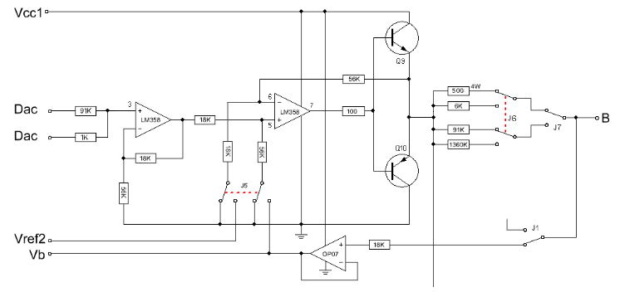

Relay J5 is controlled by the "Current Relay Test" switch. When energized it activates constant current mode, where the contacts connect IC7B pin 6 to Vref2 (about 6.2~6.8V), and IC7B pin 5 to the output of IC204(B) (OP07). The most common faults are defective Q5/6 or J5.

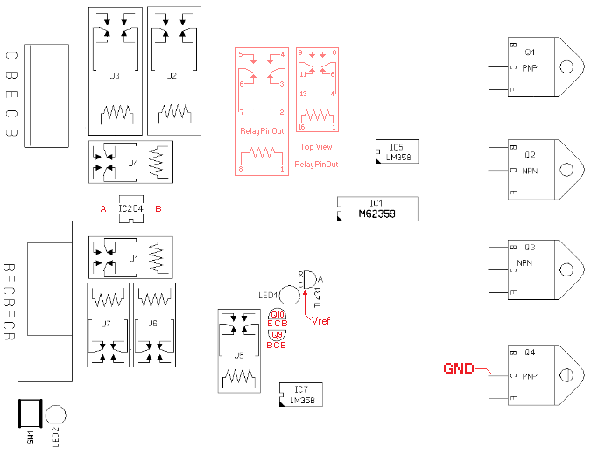

**E measurement error**

IC2 (TL431) or IC201 (ADS7871) may be faulty: Use a multimeter to verify that the voltage Vref between pin K of IC2 (TL431) and ground is between 4.6~4.8V. If it is not then IC2 (TL431) is usually damaged. If Vref is fine then IC201 (ADS7871) may have failed or there is some other problem and it is recommended to contact the author.

**C measurement error**

Relay J4 or IC201 (ADS7871) may have a problem: Keep “Channel C” output at 15V, and “Channel E” at 25V. Pin 6 of J4 is connected to the emitter of Q2, pin 8 of J4 is connected to emitter of Q4, and J4 is controlled by the "Calibration Relay Test" check-box shown below.

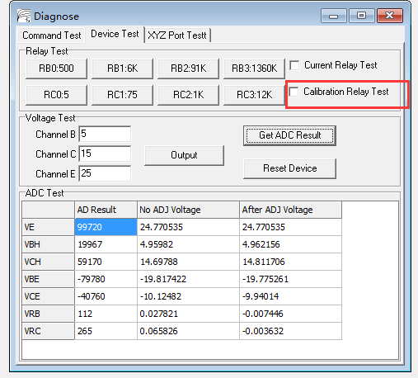

Tick the "Calibration Relay Test" checkbox shown above to connect J4 pin 4 to J4 pin 8, then clear the checkbox to revert J4 pin 4 back to J4 pin 6. Determine whether J4 is damaged by observing the results in the Diagnose window pictured above or by measuring with a meter.

If the voltage at J4 pin 4 can be controlled normally then IC201 (ADS7871) may be faulty or something else is wrong, so it is recommended to contact the author.

**B measurement error**

Possible cause of failure are relay J1 or IC201 (ADS7871): Keep “Channel B” output at 5V, and “Channel E” at 25V. Pin 11 of J1 is connected to the “Channel B” output (ie the upper pin of R12 and emitter of Q9), pin 9 of J1 is connected to emitter of Q4, and J1 is controlled by the "Calibration Relay Test" check-box shown below. Note: schematic differs from PCB artworks.



Tick the "Calibration Relay Test" checkbox shown above to connect J1 pin 13 to J1 pin 9, then clear the checkbox to revert J1 pin 13 back to J1 pin 11. Determine whether J1 is damaged by observing the results in the Diagnose window pictured above or by measuring with a meter.

If the voltage at J1 pin 13 can be controlled normally then IC201 (ADS7871) may be faulty or something else is wrong, so it is recommended to contact the author.

**Correction circuit fault**

In the curves measured by the offset test in the upper section of this document, IC204(B) and relay J1 will affect VRB/VBE, and IC204(A) and J4 will affect VRC/VCE. If VRB/VBE is abnormal while VRC/VCE is normal, then you can try exchanging IC204(B) with IC204(A) and then repeat step 4 again, to see if VRB/VBE becomes normal while VRC/VCE becomes abnormal. If so then IC204(B) can be considered defective. If the VRB/VBE curve remains abnormal then J6 might be faulty. The same testing strategy is valid in reverse for VRC/VCE.

